0th level: Amanuensis: Copy nonmagical text.

1st Level:

Anarchic WaterM: Makes chaotic-aligned anarchic water.

Axiomatic WaterM: Makes lawful-aligned axiomatic water.

Blessed Aim: +2 bonus for allies’ ranged attacks.

Blood Wind: Subject uses natural weapon at range.

Cold Fire: Fire becomes blue and white, emits cold.

Conviction: Subject gains +2 or higher save bonus.

Delay Disease: Ravages of disease staved off for a day.

Dispel Ward: As *dispel magic*, but affects only wards.

Ebon Eyes: Subject can see through magical darkness.

Faith Healing: Cures 8 hp +1/level (max +5) to worshiper of your deity.

Foundation of Stone: +2 AC, +4 bonus to resist bull rush and trip attacks.

Grave Strike: You can sneak attack undead for 1 round.

Guiding Light: +2 on ranged attacks against creatures in illuminated area.

Healthful Rest: Subjects heal at twice the normal rate.

Ice Gauntlet: A spiked gauntlet of ice forms around your fist.

Incite: Subjects can’t ready actions or delay.

Inhibit: Subject delays until next round.

Ironguts: Subject gains +5 bonus on saving throws against poison.

Light of Lunia: You radiate silvery light, which you can expend as 2 bolts that deal 1d6 damage.

Moon Lust: Subject obsesses about moon, is *fascinated* or dazzled.

Nightshield: You gain resistance bonus on saves, and spell absorbs *magic missile* damage.

Nimbus of Light: Light illuminates you until released as an attack.

Omen of PerilF: You know how dangerous the future will be.

Portal Beacon: You grant others knowledge of a magic portal’s location.

Resist Planar Alignment: Subject can resist penalties for being of an opposed alignment on an aligned Outer Plane.

Resurgence: You grant subject a second chance at a saving throw.

Sign: You gain +4 bonus on next initiative check.

Snowshoes: Subject walks easily on ice and snow.

Spell Flower: Hold the charge on one touch spell per forelimb.

Summon Undead I: Summons undead to fight for you.

Updraft: Column of wind lifts you aloft.

Vigor, Lesser: Creature heals 1 hp/round (max 15 rounds).

Vision of Glory: Subject gains morale bonus equal to your Cha modifier to one saving throw.

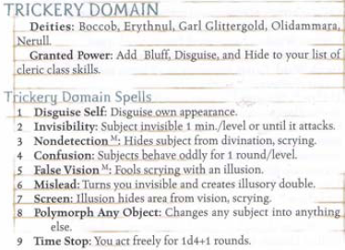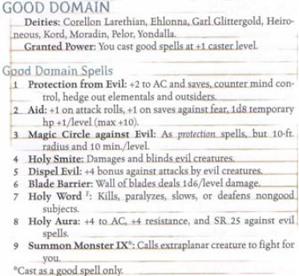Wings of the Sea: +30 ft. to subject’s swim speed.

